Kyle Salgado-Gouker
Prof. Metzger
DSC 510 – Section T304
October 30, 2022

The Popularity of Theme Parks:
Can Data Science Help Predict the Popularity of Amusement Park Attractions?

Introduction
The amusement park industry is a large piece of the world economy’s hospitality sector. In 2019, its global market size was estimated to be around $74 billion (Statista). Despite the setbacks of the Covid-19 pandemic, the industry is poised to grow to roughly $90 billion by 2023, and tens of millions of guests will annually visit one or more theme parks. Competition for these visitors is keen, and the market is constantly evolving, driven by innovative attractions such as thrill rides like VelociCoaster at Islands of Adventure and Iron Gwazi at Busch Gardens Tampa, as well as themed intellectual property like NBC Universal’s licensing of Harry Potter and Disney’s Star Wars. The cost of these new attractions also continues to climb, and decisions for new entertainment options are fraught with peril, because stakeholders expect a return on investment measured in increased guest ticket sales and other revenue. Meanwhile, industry players continually search for better ways to quantify potential guest interest, and Google Trends may provide new insight to help predict guest totals and ensure better outcomes.

Overview
Three attractions—all in Florida—were initially explored: Rock ‘n’ Rollercoaster at Disney’s Hollywood Studios, a 1999 Vekoma indoor launched coaster featuring Aerosmith; SheiKra at Busch Gardens Tampa, a B&M Dive Machine from 2005 with a 200-foot vertical drop; and Hollywood Rip Ride Rockit of Universal Studios Florida, a Maurer steel coaster opened in 2009 that features a 167-foot vertical-lift hill and an individual auditory experience where the riders select songs from different genres. As expected, Google Trends showed the relative online presence of each coaster, however, during the investigation, three other factors became evident: the importance of global markets in generating larger attendance growth, the impact of execution on an attraction’s success, and the far greater popularity of themed lands like Wizarding World of Harry Potter and Star War’s Galaxy’s Edge versus traditional thrill rides.
Analysis
Google Trends provides interesting insight for the coasters initially studied. Generally Rock n’ Roller Coaster has trended higher, outside of several positive and negative stories about Sheikra (in 2005, 2007, and 2016) and the delayed launch of Rockit (2009):
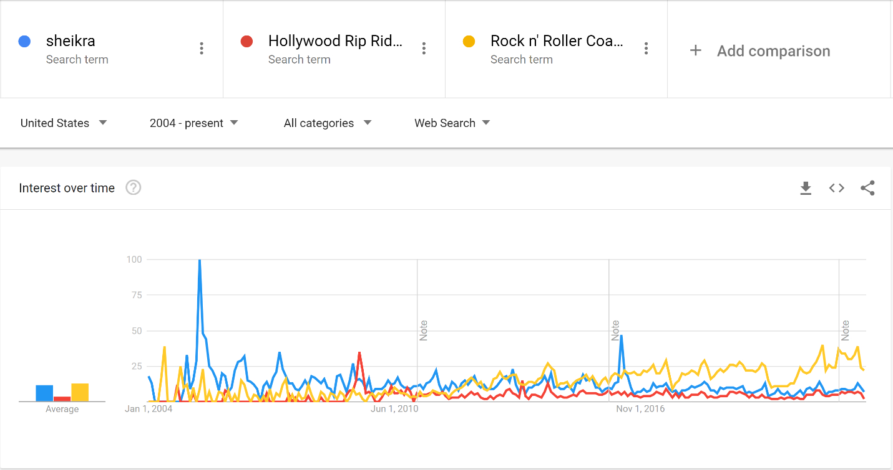
Trends, however, reveals that themed lands like Wizarding World of Harry Potter are more popular than traditional coasters. The following Trends graph compares Wizarding World with Hollywood Rip Ride Rockit:
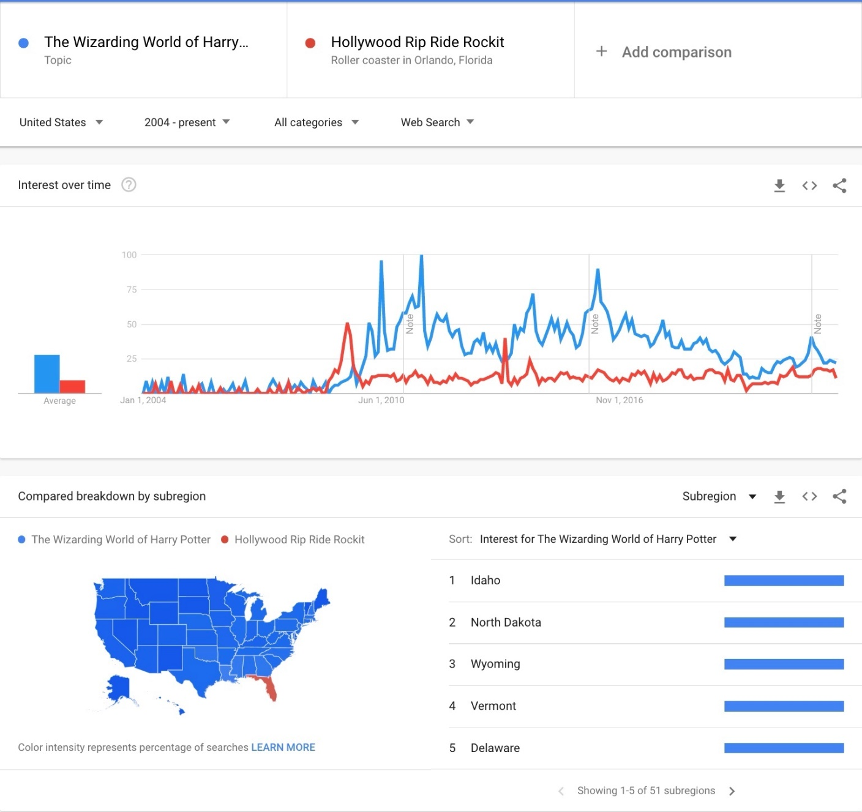
Note the comparative impact of Wizarding World! Also note that Rockit only trends higher than Wizarding World in Florida. This observation, combined with the TravelPulse estimation that “international travelers make up 10-to-20 percent of total visitors... buying more souvenirs and other high-profit items,” leads to questions about how well Google Trends could also measure guest interest of other regions, including outside the United States.
Amusement parks perceive three different groups of visitors: regional, domestic, and global. They have distinct characteristics. Regional guests visit more often but spend less, because they do not require accommodations. Some parks offer special discounts as incentives for in-state guests. Most valuable of all are international tourists, who “spend more, stay longer and travel midweek and during off-peak seasons” (MacDonald). For theme parks like Disney World and Universal Studios, they account for a significant share, and corporations have taken notice. In 2013, Quartz reported 20% of Orlando’s international visitors were Brazilians with a double digit growth rate thanks to an aggressive advertising campaign. Clearly, it is important to dive further into the trends to determine from where the worldwide interest originates. We begin more prosaically, though, by assessing the scale of domestic and regional interest for two Florida theme parks, Universal Orlando and Walt Disney World, a pure amusement park in Ohio with incredible thrill rides (Cedar Point), and a hybrid in Tampa, Florida, Busch Gardens:
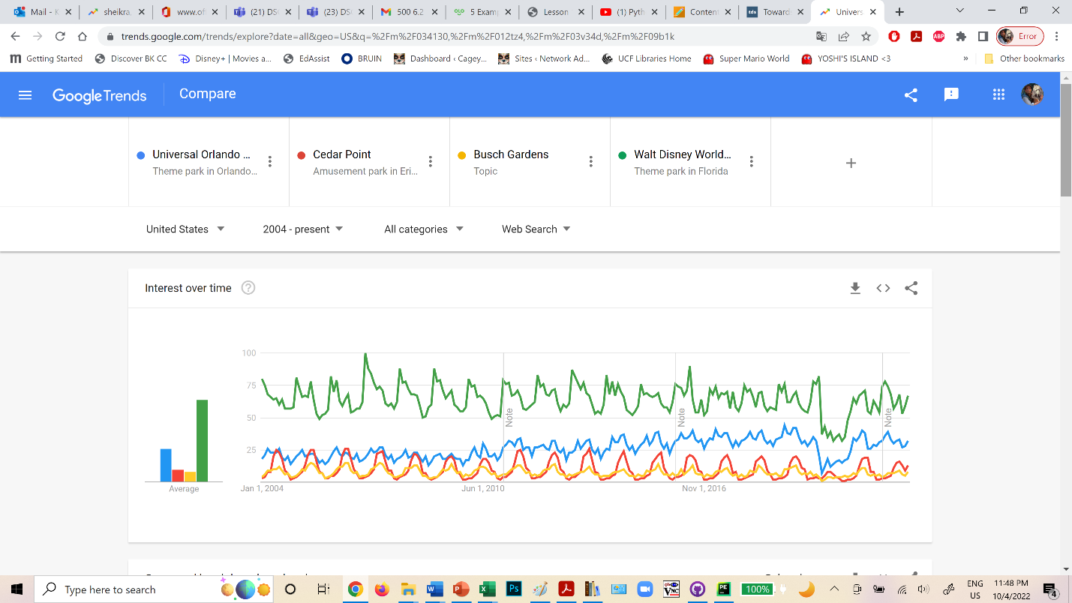
Aside from the previously mentioned ascent of Universal after 2010, that paralleled the launching of Wizarding World of Harry Potter, and the absolute dominance of Disney, another notable feature for Cedar Point is an almost sinusoid-like seasonal wave and a general lack of growth. Nevertheless, investors see potential. In fact, Cedar Fair, the owner of 13 amusement parks, has twice been a recent takeover target, in 2019 by Six Flags, and in February 2022 by Sea World Entertainment. It is safe to say such interest is not from Floridians however:
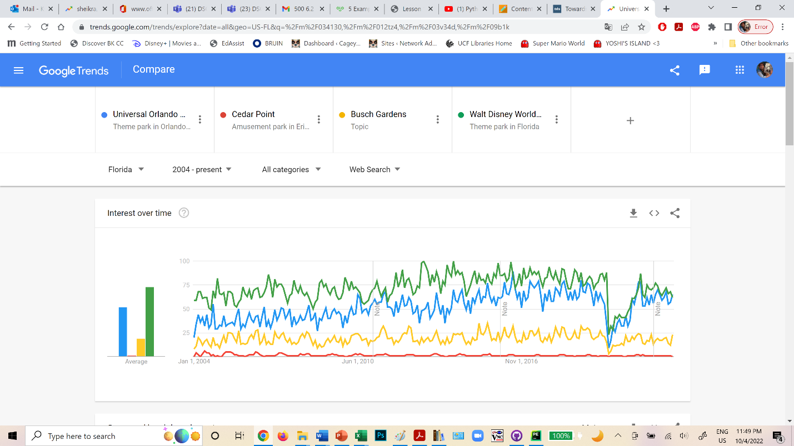
Unsurprisingly, Trends shows Cedar Point interest dominant in Ohio, but even Disney and Universal register, while the attraction of Busch Gardens is similar to Cedar Point interest in Florida. This points to a wider penetration of the theme parks.
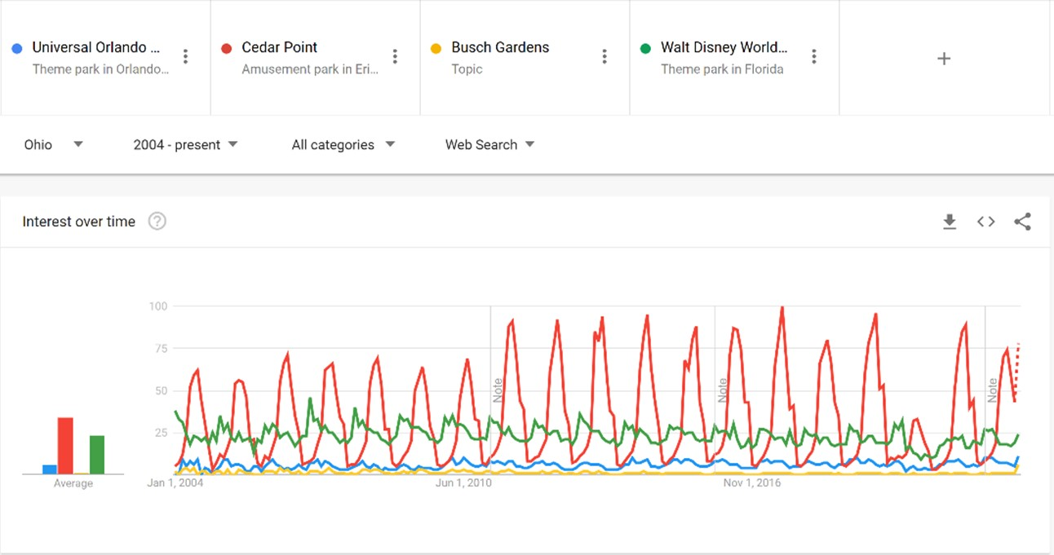
Indeed the breakdown by subregion illustrates this even more. Cedar Point is only dominant in Ohio and nearby Michigan.
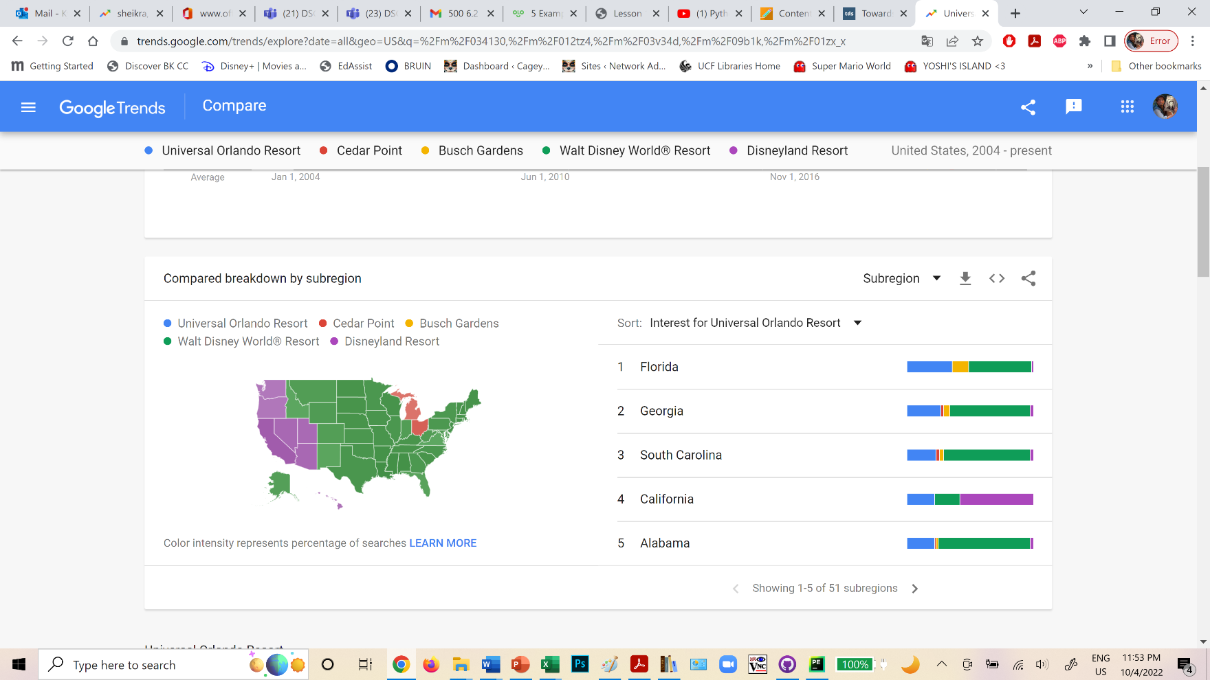
Google Trends reveals fascinating international interest. In Brazil, Universal Orlando is highly competitive with Disney, while the other parks are significantly less searched. Also, in the “Related Queries” section for Universal, the 6th ranking is “Harry Potter”:
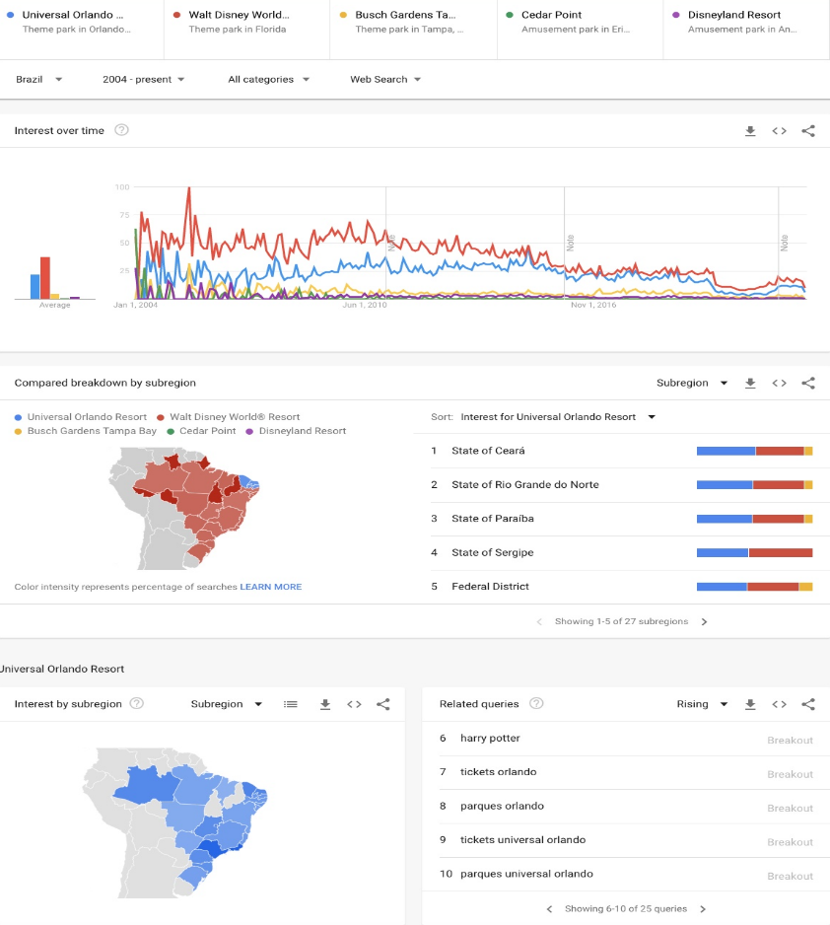
Unsurprisingly, another large tourist contingent, those of the United Kingdom, also displays greater attraction to the Wizarding World since 2010:
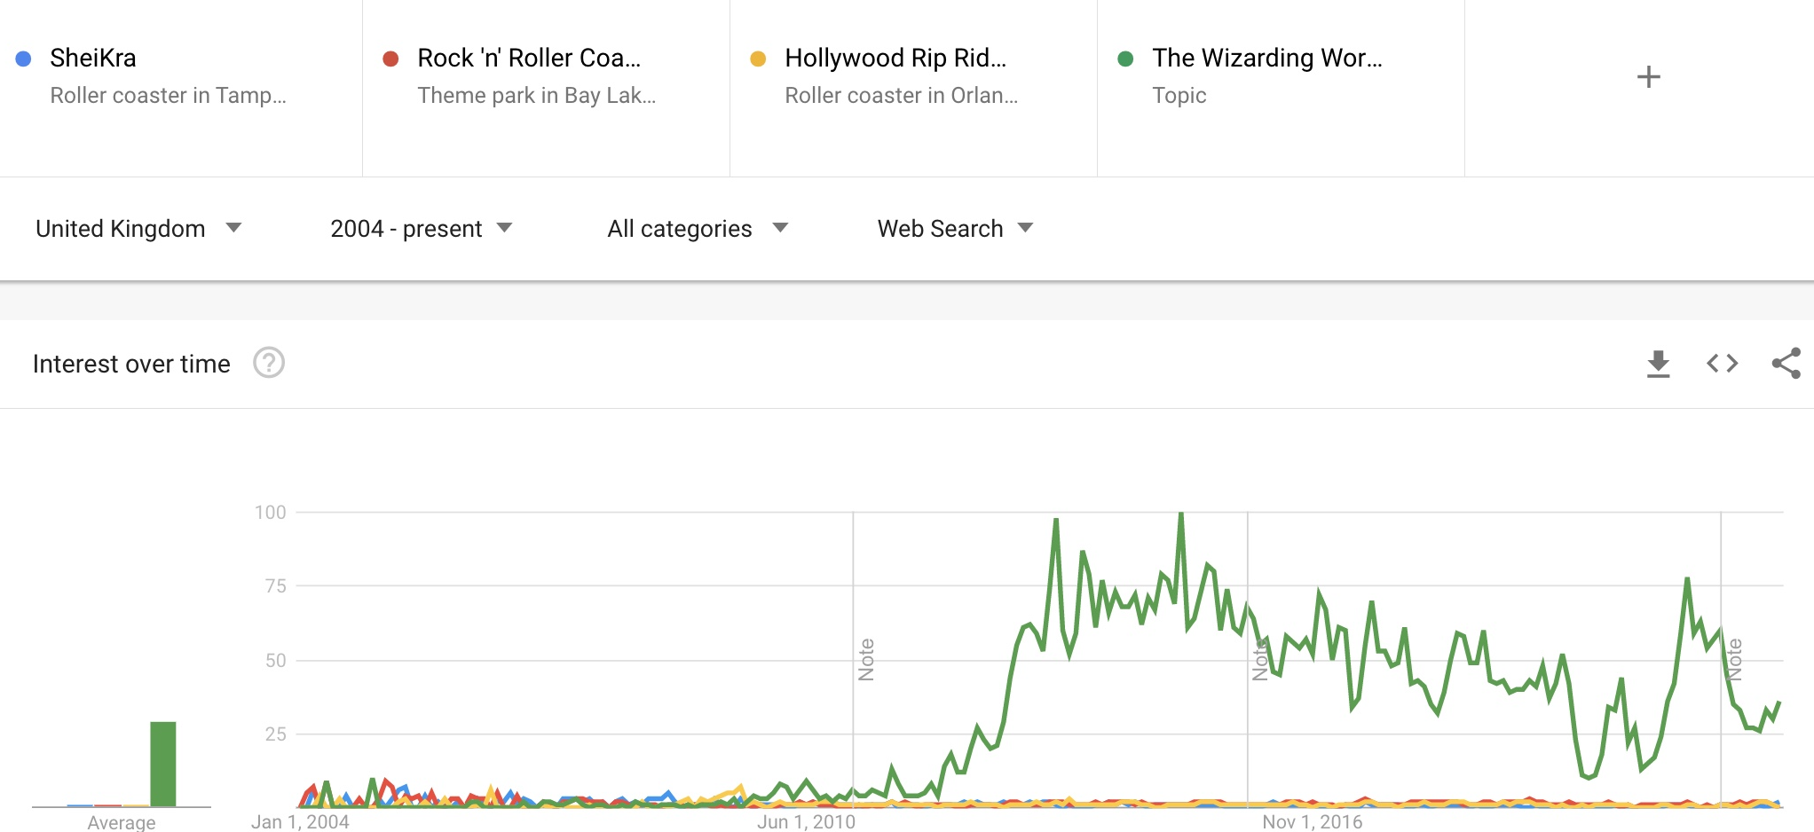
Google Trends confirms the earlier findings, although the data is considerably sparser in Brazil, where Portuguese is spoken, and few would refer to The Wizarding World of Harry Potter or Star Wars: Galaxy’s Edge by their English names. This demonstrates a limitation in basing research solely on Internet search tools: the assumption that speakers of other languages will use English search terms to conduct their Internet queries. Another assumption is that all themes are not created equal. It is possible to spend millions of dollars on intellectual property and implementation and still fail, because the attraction is unpopular with guests. A notorious example is “Fast & Furious Supercharged” at USF being generally a walk-on.
Another important question is the lasting effect of an attraction’s popularity. Here again, the success of themed attractions persisted longer, and paralleled increased ticket sales as seen in the steady rise of Islands of Adventure (IOA) and Universal Studios Florida (USF) compared to Sea World (SWO) and Busch Gardens Tampa (BGT) in the graph below:
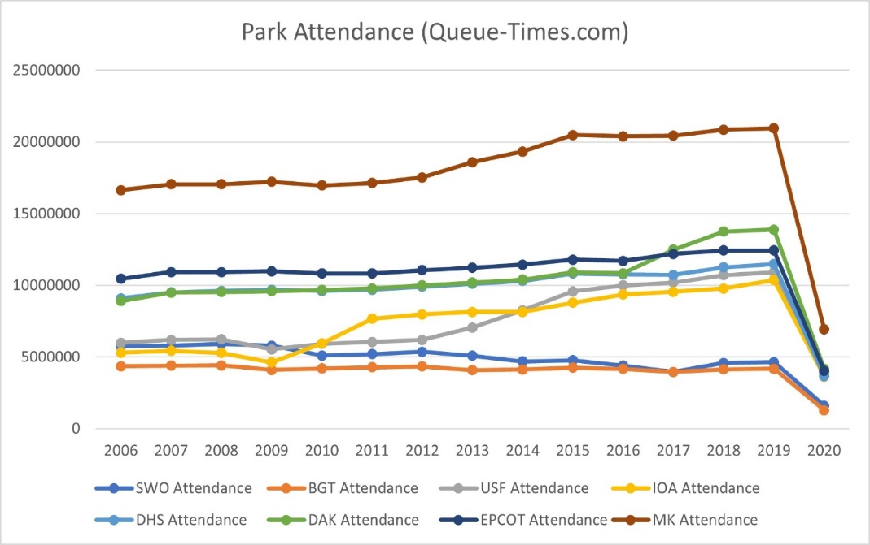
Traditional data corroborates the Google Trends findings. For example, another way to independently determine an attraction’s popularity is to analyze nearby restaurants, because if people are queueing for a ride, they are likely eating nearby too, and this information is freely accessible in Google, Yelp, and Trip Advisor reviews. The Wizarding World of Harry Potter has award-winning restaurants like Three Broomsticks and the Leaky Cauldron. Scraping the reviews of nearby restaurants confirms how popular themed attractions are compared to roller coasters.

Clearly, the restaurants at Universal near the Wizarding World of Harry Potter have greater popularity. Two Disney themed areas added to the chart, Galaxy’s Edge (Star Wars) and Pandora (Avatar), also garner more guest reviews. This observation reinforces the same outcomes determined by Google Trend analysis.
Additionally, roller coaster fanatics review rides on sites like Captain Coaster, which has full API access for developers and data scientists. There are surprising results when comparing SheiKra, Rock ‘n’ Rollercoaster, and Hollywood Rip Ride Rockit with themed coasters like Harry Potter and the Escape From Gringotts, a 2014 coaster and dark ride hybrid at Universal Studios Florida with a 25-mph top speed and frequent stops for storytelling scenes; Hagrid’s Magical Creatures, a 2019 launched outdoor coaster at Islands of Adventure with an innovative motorbike and sidecar ride vehicle; Superman Escape from Krypton, an Intamin Freefall Coaster at Six Flags Magic Mountain, over 400 feet tall with a top speed of 100 mph; and Epcot’s Guardians of the Galaxy: Cosmic Rewind, an indoor launched spinning coaster from 2022 where riders listen to a random song out of six while a story is being told. Despite modest excitement metrics like speed and altitude, some themed coasters rank the same or higher as great thrill rides:
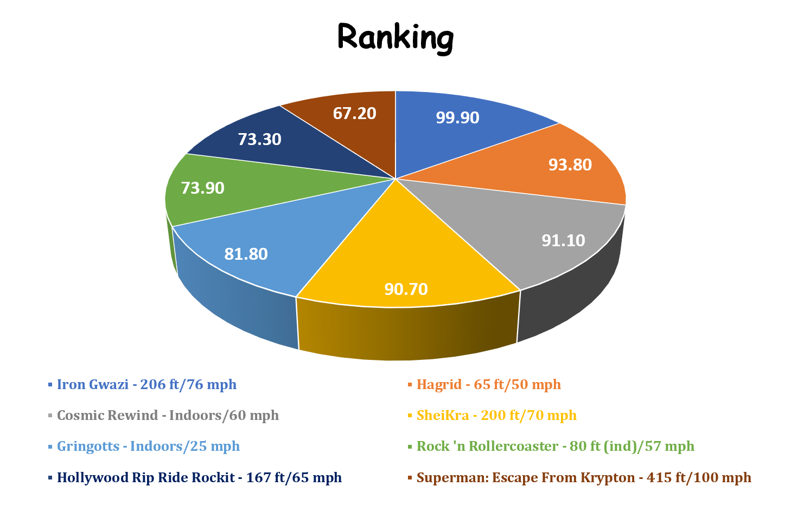
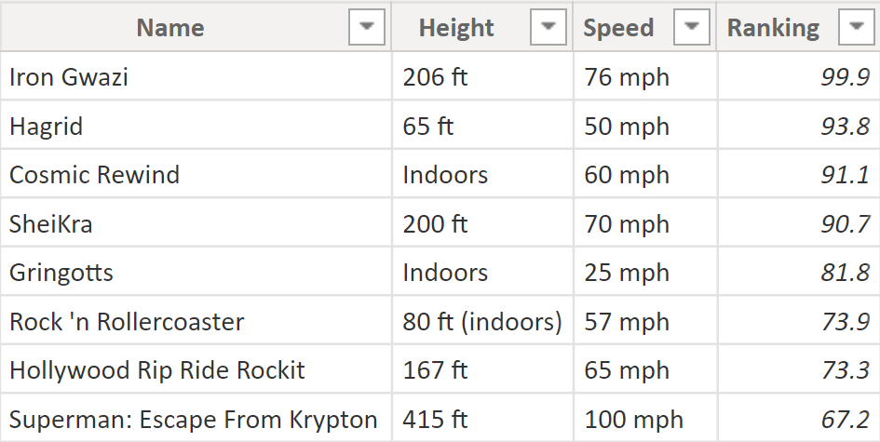
With such compelling evidence that themed attractions draw more guests, it is reasonable to question why non-themed rides are still built. One major reason is the additional expense for successful intellectual property and the challenge to secure its rights. This is the battlefield where theme park success will likely be fought.
The Marvel Cinematic Universe, purchased by Disney in 2009 for $4,000,000,000 is illustrative. In 1994, the Marvel Entertainment Group signed a deal with MCA, the owner of Universal Orlando at the time. The contract allowed Universal to build and maintain a “Marvel Universe,” and the contract would remain in “perpetuity” unless Universal chooses to close Marvel, stops making payments for licensing, or Marvel opts out of the contract feeling that the brand is “suffering” at Universal. Therefore, even though Disney now owns the MCU, it does not own rights to some of the characters east of the Mississippi River. Universal’s Marvel Super Hero Island features the Fantastic Four, X-Men, Avengers, and Spider-Man, but Walt Disney World in Lake Buena Vista cannot use these characters in rides or meet-and-greets, though others, such as Guardians of the Galaxy, are fair game.
Sometimes IP cost savings are questionable. One example is Rock ‘n’ Rollercoaster at Disney’s Hollywood Studios. Originally, the ride would have featured The Rolling Stones instead of Aerosmith, however Disney saved $10 million by choosing a less popular band and while still a successful ride, the question remains whether this was a good decision:
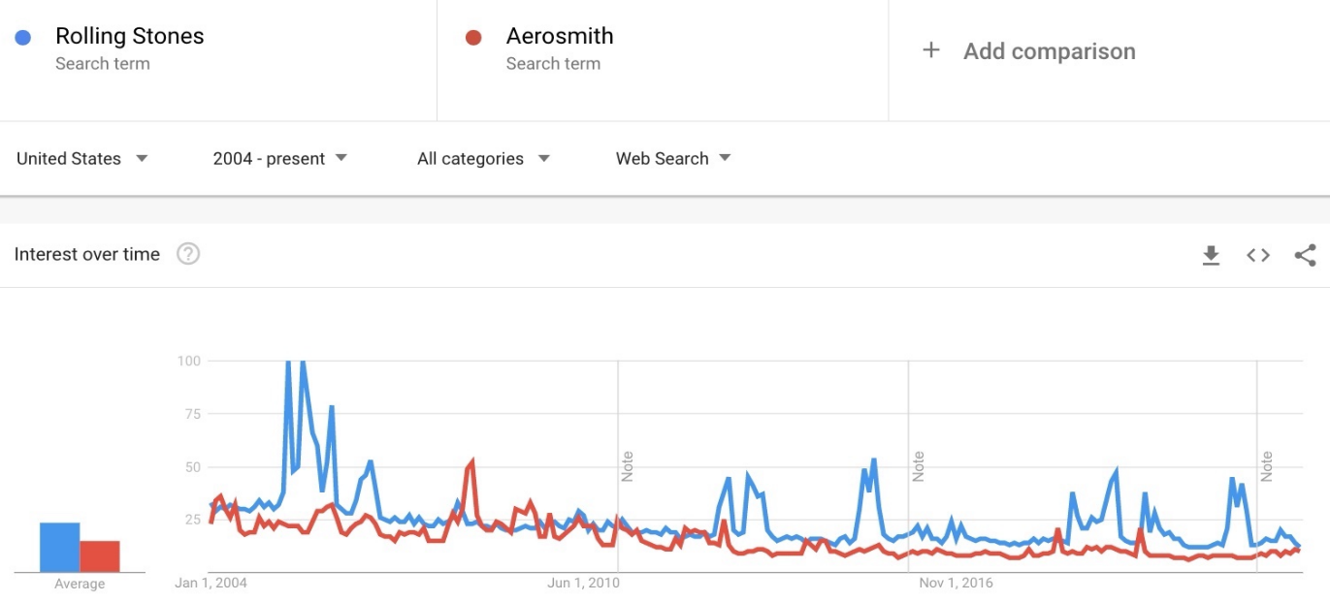
Curiously, solely in Brazil, Google Trends shows Aerosmith to be more popular in almost every state, and it is impossible not to wonder whether this is a side-effect of Disney’s branding choice and how much more appealing a Rolling Stones attraction might have been:

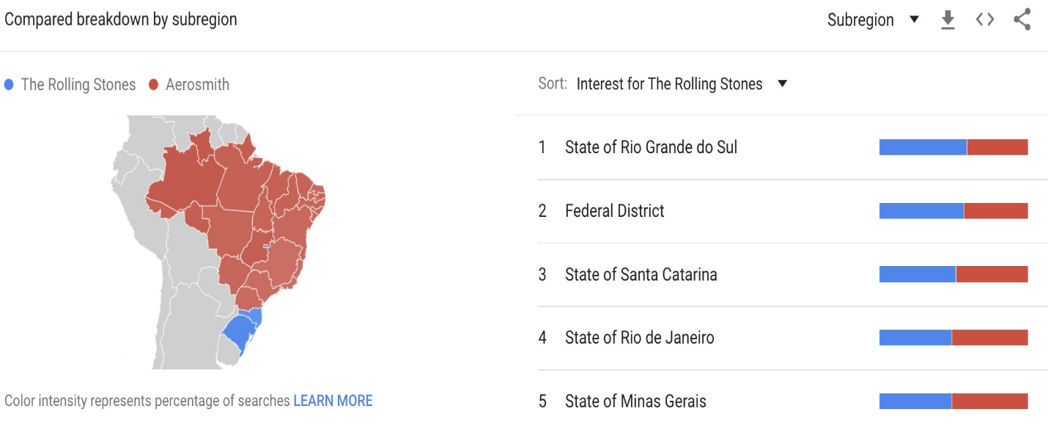

Further Steps
Google Trends provides a unique perspective for measuring guest interest, but another way to determine the impact of new attractions is to survey guests at the park or during ticket sales. Likewise, guests can be encouraged to tag their favorite rides on social media. There are powerful APIs for Twitter, YouTube, Instagram, TikTok and others, which can be used by industry data scientists to enhance research of guest satisfaction. Also, parks often show images or ride stats of new attractions on shirts, drinkware, and other merchandise, and those sales totals (easily available through in-house inventory systems) may also indicate the ride’s popularity. Additionally, featuring attractions on promotional material can further assess their impact on ticket sales.
Challenges/Ethical Concerns
These methods are not without flaws. Not all guests are willing to be surveyed and some parks prohibit employees and their relatives from participating, because they might bias the data. In the case of social media tagging, violations of guest privacy are possible. Moreover, some guests keep their accounts private, so it may be even impossible to acquire accurate readings. Merchandise sales are definitely easier to quantify; still, there are some items that feature multiple attractions, so these too can be unclear. Advertisements can create ticket sales, but it is hard to distinguish the effect of a given attraction from seasonal variations.
Conclusion
Google Trends demonstrates that the online popularity of attractions largely parallels their success. Also, this research is further vindicated by traditional research from TripAdvisor, Yelp, and Google restaurant reviews, as well as the Captain Coaster roller coaster fanatic site. From our analysis, several interesting actionable outcomes are evident. First, regional analysis allows better targeting of advertising campaigns especially globally. Second, execution matters—whether construction delays or bad publicity, negative online trends can seriously damage an attraction’s success. Finally, themed attractions are more conducive to wider audiences than traditional thrill rides, and their impact is longer lasting. The work presented thus far can be vastly enhanced using social media, especially programmatically with Python and the various APIs, but it is imperative that user rights to privacy are also maintained. Altogether, though, the tools of data science can improve the future of theme park attraction design and implementation.
Sources:
Glenn, Brian. May 6, 2016. “That Darn Marvel Contract – What Rights Does Universal and Disney Own”. Retrieved October 6, 2022, from https://www.insideuniversal.net/2016/05/darn-marvel-contract-what-rights-does-universal-and-disney-own/
Google. (n.d.). Google Trends. Retrieved September 13, 2022, from https://trends.google.com/
MacDonald, Brady. October 27, 2021. “Surge of International Travelers Coming to Disneyland and Other California Theme Parks.” Retrieved October 6, 2022, from https://www.ocregister.com/2021/10/27/surge-of-international-travelers-coming-to-disneyland-and-other-california-theme-parks/
Queue Times. (n.d.). Retrieved September 14, 2022, from https://queue-times.com/en-US/parks
Statista. January 14, 2022. “Global Theme Parks Market Size”. Retrieved September 15, 2022, from https://statista.com/statistics/1180141/amusement-parks-market-size-worldwide/
The Mouse For Less. (n.d.). “Rock ‘n’ Roller Coaster Starring Aerosmith”. Retrieved October 4, 2022, from https://www.themouseforless.com/walt-disney-world/parks/disneys-hollywood-studios/rock-n-roller-coaster-starring-aerosmith/
Wood, Donald. November 12, 2021. “American Theme Parks Will See Spike in International Visitors Next Year”. Retrieved October 7, 2022, from https://www.travelpulse.com/news/entertainment/american-theme-parks-will-see-spike-in-international-visitors-next-year.html
Yanofsky, David. September 27, 2013. “More than a third of Brazilians who travel to the US go to the happiest place on earth”. Retrieved October 5, 2022, from https://qz.com/128367/the-happiest-place-on-earth-is-full-of-brazilians/

